This is an assignment you need to complete within provided deadlines. And must follow the guidelines described to solve this assignment.

In this assignment you need to build a job posting for where a recruiter can post a job, we will be sharing the details about how it should be built and what are the fields that should be present in the job posting form.

Please finds the example job posting for below for your reference

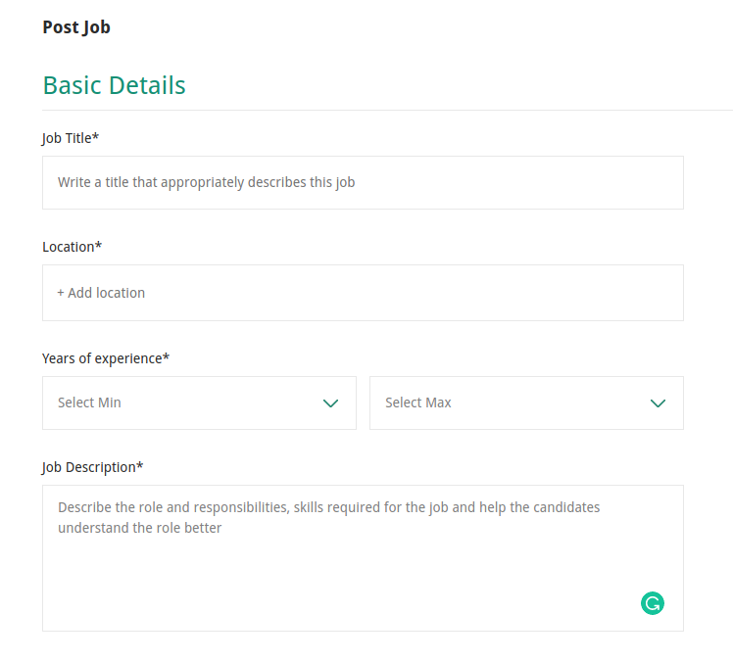

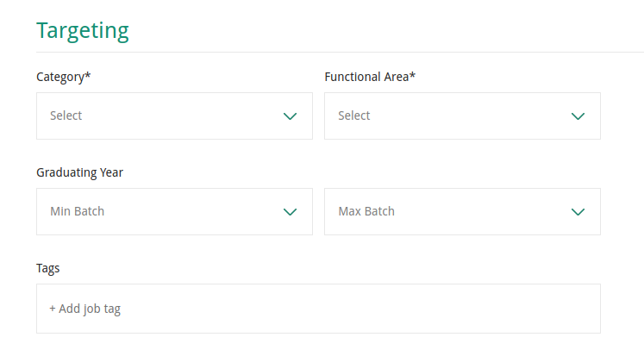

**Guidelines**

* Validation needs to added to each fields as necessary
* On clicking the “Post Job” it should post form data at localhost:8001/v1jobs/job (You no need to design backend just post data on route which is non existent)

format could be like this

{

"Title": "Full Stack developer Updated",

"Locations": ["Pune", "Bangalore"],

"MustHaveSkills": ["ReactJS"],

"YearsOfExperience": "5+",

"Category": ["Software Dev"],

"EmploymentType": "Full Time"

}

* User ReactJS with Javascript or Typescript
* New github repository needs to be created
* Make assumptions wherever necessary

**Evaluation**

* Completeness of the solution
* Coding practices and modularity
* Github commits history

Thanks,

Best of luck for the assignment